Adding a controlled vocabulary for local license terms | 

As of the February 2018 release it is possible to add a controlled vocabulary for local license terms.

This is useful to ensure that the same values are added in different licenses for the same terms.

The License Term Controlled Vocabulary is relevant for license terms of type “Controlled Vocabulary”.

From the acquisitions configuration menu choose “Manage License Terms” and then “Add License Term”.

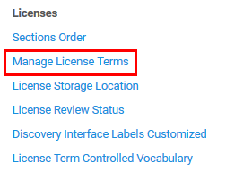

Fill in the fields as desired and for “License Term Type” choose “Controlled Vocabulary”.

When you choose “Controlled Vocabulary” as the “License Term Type” an option “Add value” will appear on the bottom right.

In the example below we are adding local license term code RMBDL for local license term name “Resource may be downloaded locally”.

It is “License Term Type” “Controlled Vocabulary” and therefore we have the “Add Value” option

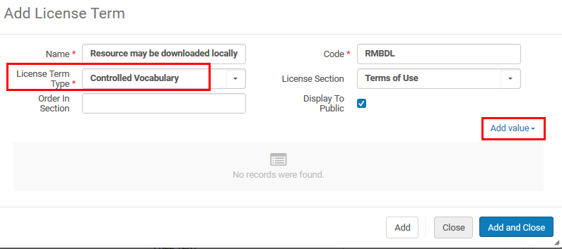

After clicking “Add value” entered the desired value of the controlled vocabulary for the term and click “Add”. Repeat as desired to add several values. Here we add value “May be downloaded when on campus”.

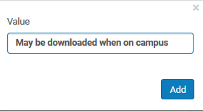

The new controlled vocabulary license term will appear in the list of license terms and may be edited from the list:

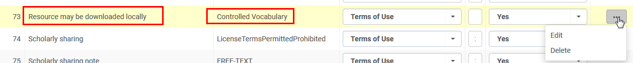

After clicking “Edit” from the list of license terms you can continue to add new controlled vocabulary values:

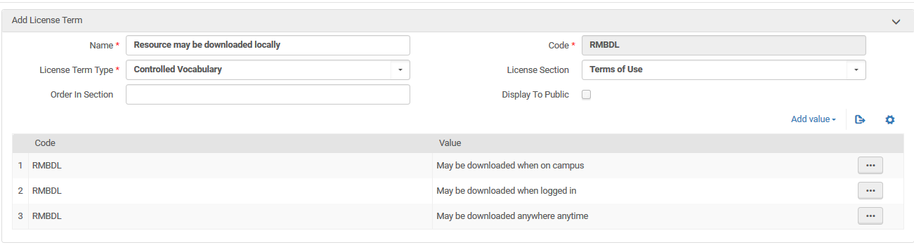

It is also possible to edit the list of controlled vocabulary directly from the controlled vocabulary mapping table.
To do so: from the acquisitions configuration menu choose “License Term Controlled Vocabulary”

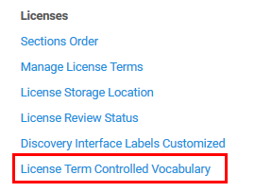

Now you can click “Add Row” and add another term for license term code RMBDL or any other license term.

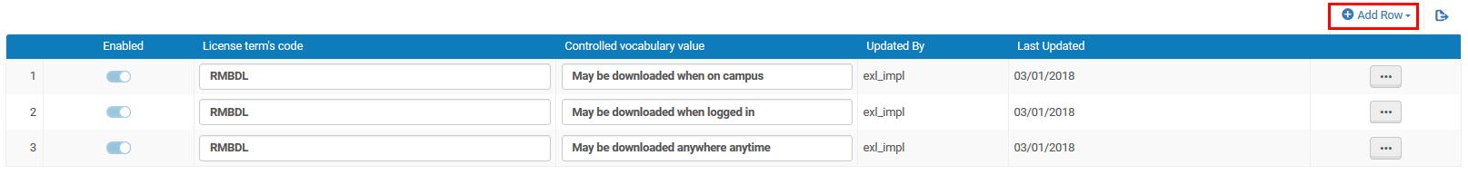

Now we add another term

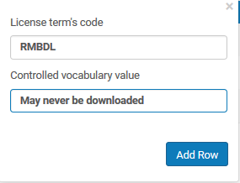

And here it is:

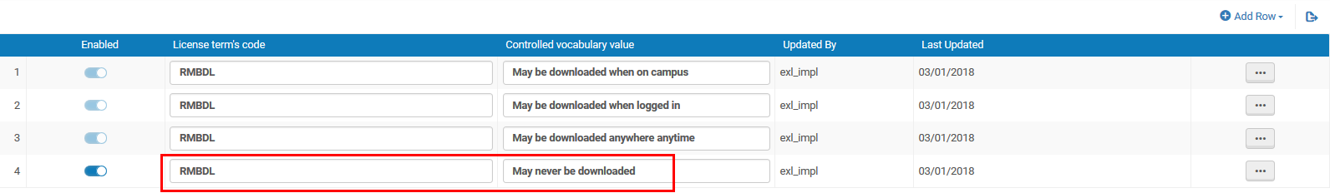

Now when adding a license term to a license I see the new local term and can choose from the controlled vocabulary

